Assignment - 3
Application for TGNPDCL
Objective: Build an application using Python program for TGNPDCL, to generate the bill based on energy consumption and type of customer with the help of AI tools.
Build a python application as per below instructions
• Read all the required data like PU,CU and Type of customer
• Calculate bill amount based on number of units consumed, type of customer
and other charges
• Finally print the values of EC(Energy Charges),FC(Fixed
Charges),CC(Customer Char-ges),ED(Electricity Duty Charges),bill as per
expected output
Requirements:
• VS Code with Github Copilot and/or Google Colab with Gemini
• Students should bring power bill from their home
Deliverables:
• Print energy bill for given inputs and verify with bill taken by students

Code :

TGNPDCL - Assignment
Interactive wrapper for the TGNPDCL bill calculator.
Prompts the user for:
- CU: previous meter reading
- PU: present meter reading
- or directly number of units (enter blank to use readings)
- customer type (residential/commercial)
Computes EC, FC, CC, ED and prints the bill breakdown.
This file is intended as the student's submission file. It imports the
calculator implementation from `tgnpdcl_bill.py` (created alongside this file).
If you prefer a single-file submission, let me know and I'll merge them.

from tgnpdcl_bill import calculate_bill, format_currency

def prompt_float(prompt_text: str):
s = input(prompt_text).strip()
if s == "":
return None
try:
return float(s)
except ValueError:
print("Invalid number. Leaving blank to skip.")
return None

def main():
print("TGNPDCL - Energy Bill Generator\n")
print("Enter previous and present meter readings (CU = previous, PU = present).")
print("You may leave them blank and instead enter units directly.")
cu = prompt_float("Enter Previous reading (CU): ")
pu = prompt_float("Enter Present reading (PU): ")
units = None
if cu is not None and pu is not None:
units = pu - cu
if units < 0:
print("Warning: Present reading less than previous reading. Taking absolute difference.")
units = abs(units)
print(f"Calculated units from readings: {units}")
else:
u = prompt_float("Enter units consumed directly (leave blank to use readings): ")
if u is not None:
units = u
if units is None:
print("No valid units provided. Exiting.")
return
print("\nCustomer types available: residential, commercial")
ctype = input("Enter customer type: ").strip()
try:
bill = calculate_bill(units, ctype)
except Exception as e:
print(f"Error calculating bill: {e}")
return
print("\n--- Energy Bill ---")
print(f"Energy Charges (EC): {format_currency(bill['EC'])} INR")
print(f"Fixed Charges (FC): {format_currency(bill['FC'])} INR")
print(f"Customer Charges (CC): {format_currency(bill['CC'])} INR")
print(f"Electricity Duty (ED): {format_currency(bill['ED'])} INR")
print("-------------------------------")
print(f"Total Payable: {format_currency(bill['Total'])} INR")
if __name__ == '__main__':
main()

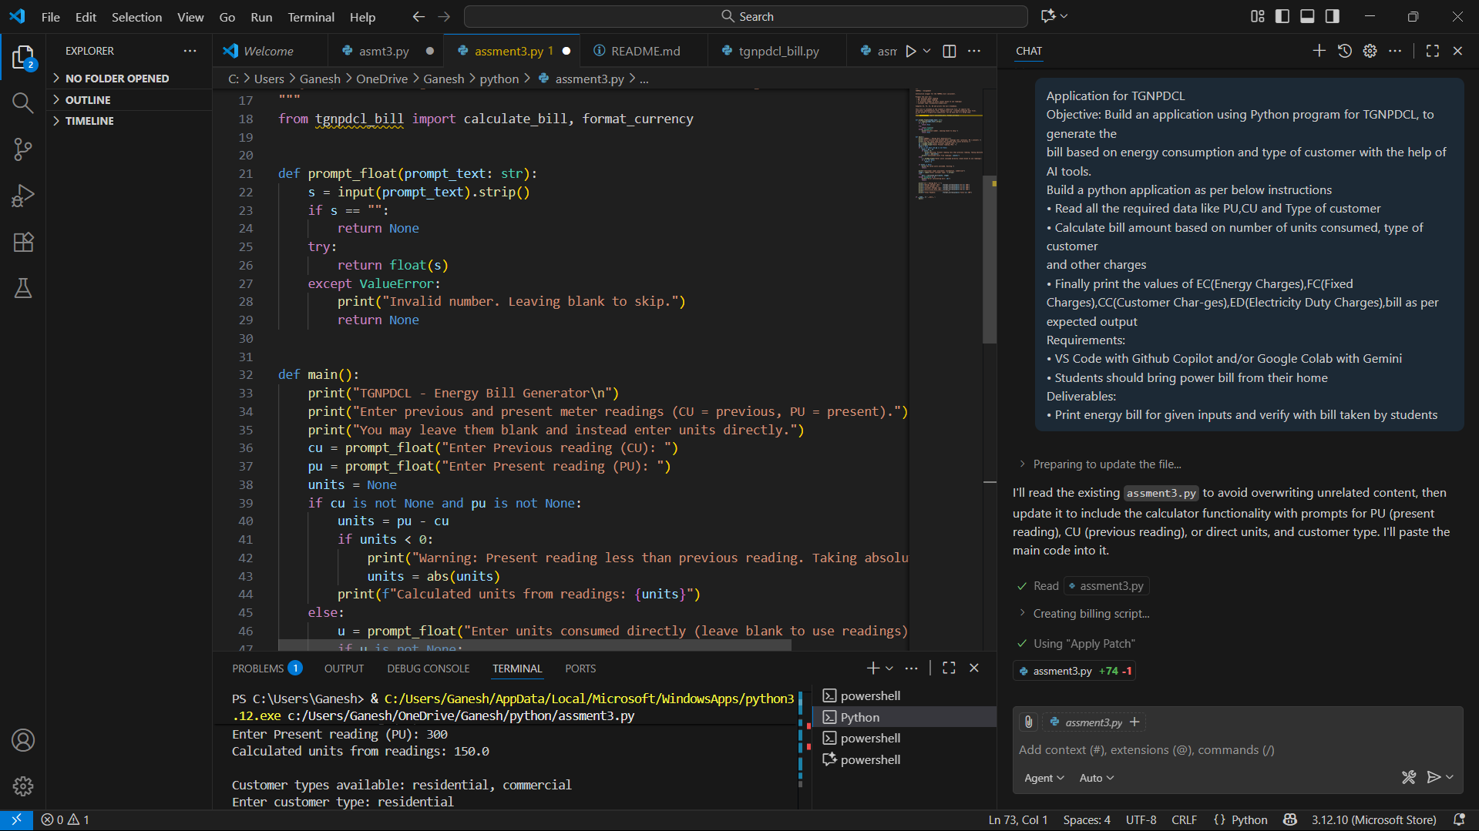
OutPut :
TGNPDCL - Energy Bill Generator

Enter previous and present meter readings (CU = previous, PU = present).
You may leave them blank and instead enter units directly.
Enter Previous reading (CU): 150
Enter Present reading (PU): 300
Calculated units from readings: 150.0

Customer types available: residential, commercial
Enter customer type: commercial

--- Energy Bill ---
Energy Charges (EC): 825.00 INR
Fixed Charges (FC): 200.00 INR
Customer Charges (CC): 50.00 INR
Electricity Duty (ED): 49.50 INR
-------------------------------
Total Payable: 1,124.50 INR

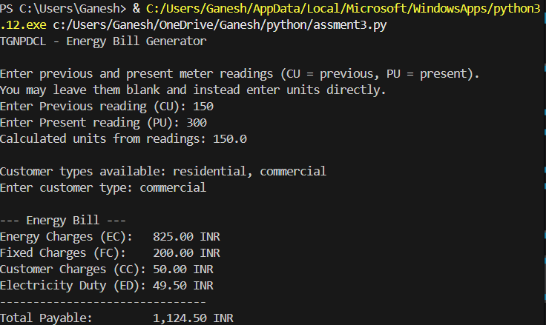
OutPut :
TGNPDCL - Energy Bill Generator

Enter previous and present meter readings (CU = previous, PU = present).
You may leave them blank and instead enter units directly.
Enter Previous reading (CU): 150
Enter Present reading (PU): 300
Calculated units from readings: 150.0

Customer types available: residential, commercial
Enter customer type: residential

--- Energy Bill ---
Energy Charges (EC): 525.00 INR
Fixed Charges (FC): 50.00 INR
Customer Charges (CC): 25.00 INR
Electricity Duty (ED): 26.25 INR
-------------------------------
Total Payable: 626.25 INR

